**Mobile Computing Chapter-II (Medium Access Control)**

1. **Motivation for a specialized MAC**

One of the most commonly used MAC schemes for wired networks is carrier sense multiple access with collision detection (CSMA/CD). In this scheme, a sender senses the medium (a wire or coaxial cable) to see if it is free. If the medium is busy, the sender waits until it is free. If the medium is free, the sender starts transmitting data and continues to listen into the medium. If the sender detects a collision while sending, it stops at once and sends a jamming signal. But this scheme doest work well with wireless networks. The problems are:

* Signal strength decreases proportional to the square of the distance
* The sender would apply CS and CD, but the collisions happen at the receiver
* It might be a case that a sender cannot “hear” the collision, i.e., CD does not work
* Furthermore, CS might not work, if for e.g., a terminal is “hidden”

**Hidden and Exposed Terminals**

Consider the scenario with three mobile phones as shown below. The transmission range of A Reaches B, but not C (the detection range does not reach C either). The transmission range of C Reaches B, but not A. Finally, the transmission range of B reaches A and C, i.e., A cannot detect C and vice versa.



**Hidden terminals**

* A sends to B, C cannot hear A
* C wants to send to B, C senses a “free” medium (CS fails) and starts transmitting
* Collision at B occurs, A cannot detect this collision (CD fails) and continues with its transmission to B
* A is “hidden” from C and vice versa

**Exposed terminals**

* B sends to A, C wants to send to another terminal (not A or B) outside the range
* C senses the carrier and detects that the carrier is busy.
* C postpones its transmission until it detects the medium as being idle again
* but A is outside radio range of C, waiting is **not** necessary
* C is “exposed” to B

Hidden terminals cause collisions, whereas Exposed terminals causes unnecessary delay.

**Near and far terminals**

Consider the situation shown below. A and B are both sending with the same transmission power.



* Signal strength decreases proportional to the square of the distance
* So, B’s signal drowns out A’s signal making C unable to receive A’s transmission
* If C is an arbiter for sending rights, B drown out A’s signal on the physical layer making C unable to hear out A.

The **near/far effect** is a severe problem of wireless networks using CDM. All signals should arrive at the receiver with more or less the same strength for which Precise power control is to be implemented.

1. **SDMA**

**Space Division Multiple Access (SDMA)** is used for allocating a separated space to users in wireless networks. A typical application involves assigning an optimal base station to a mobile phone user. The mobile phone may receive several base stations with different quality. A MAC algorithm could now decide which base station is best, taking into account which frequencies (FDM), time slots (TDM) or code (CDM) are still available. The basis for the SDMA algorithm is formed by cells and sectorized antennas which constitute the infrastructure implementing **space division multiplexing (SDM).** SDM has the unique advantage of not requiring any multiplexing equipment. It is usually combined with other multiplexing techniques to better utilize the individual physical channels.

1. **FDMA**

Frequency division multiplexing (FDM) describes schemes to subdivide the frequency dimension into several non-overlapping frequency bands.



Frequency Division Multiple Access is a method employed to permit several users to transmit simultaneously on one satellite transponder by assigning a specific frequency within the channel to each user. Each conversation gets its own, unique, radio channel. The channels are relatively narrow, usually 30 KHz or less and are defined as either transmit or receive channels. A full duplex conversation requires a transmit & receive channel pair. FDM is often used for simultaneous access to the medium by base station and mobile station in cellular networks establishing a duplex channel. A scheme called **frequency division duplexing (FDD)** in which the two directions, mobile station to base station and vice versa are now separated using different frequencies.****

**FDM for multiple access and duplex**

The two frequencies are also known as **uplink**, i.e., from mobile station to base station or from ground control to satellite, and as **downlink**, i.e., from base station to mobile station or from satellite to ground control. The basic frequency allocation scheme for GSM is fixed and regulated by national authorities. All uplinks use the band between 890.2 and 915 MHz, all downlinks use 935.2 to 960 MHz. According to FDMA, the base station, shown on the right side, allocates a certain frequency for up- and downlink to establish a duplex channel with a mobile phone. Up- and downlink have a fixed relation. If the uplink frequency is fu = 890 MHz + n·0.2 MHz, the downlink frequency is fd = fu + 45 MHz, i.e**., fd = 935 MHz + n·0.2 MHz** for a certain channel n. The base station selects the channel. Each channel (uplink and downlink) has a bandwidth of 200 kHz.

This scheme also has disadvantages. While radio stations broadcast 24 hours a day, mobile communication typically takes place for only a few minutes at a time. Assigning a separate frequency for each possible communication scenario would be a tremendous waste of (scarce) frequency resources. Additionally, the fixed assignment of a frequency to a sender makes the scheme very inflexible and limits the number of senders.

1. **TDMA**

A more flexible multiplexing scheme for typical mobile communications is time division multiplexing (TDM). Compared to FDMA, time division multiple access (TDMA) offers a much more flexible scheme, which comprises all technologies that allocate certain time slots for communication. Now synchronization between sender and receiver has to be achieved in the time domain. Again this can be done by using a fixed pattern similar to FDMA techniques, i.e., allocating a certain time slot for a channel, or by using a dynamic allocation scheme.



Listening to different frequencies at the same time is quite difficult, but listening to many channels separated in time at the same frequency is simple. Fixed schemes do not need identification, but are not as flexible considering varying bandwidth requirements.

**4.1 Fixed TDM**

The simplest algorithm for using TDM is allocating time slots for channels in a fixed pattern. This results in a fixed bandwidth and is the typical solution for wireless phone systems. MAC is quite simple, as the only crucial factor is accessing the reserved time slot at the right moment. If this synchronization is assured, each mobile station knows its turn and no interference will happen. The fixed pattern can be assigned by the base station, where competition between different mobile stations that want to access the medium is solved.



The above figure shows how these fixed TDM patterns are used to implement multiple access and a duplex channel between a base station and mobile station. Assigning different slots for uplink and downlink using the same frequency is called **time division duplex (TDD)**. As shown in the figure, the base station uses one out of 12 slots for the downlink, whereas the mobile station uses one out of 12 different slots for the uplink. Uplink and downlink are separated in time. Up to 12 different mobile stations can use the same frequency without interference using this scheme. Each connection is allotted its own up- and downlink pair. This general scheme still wastes a lot of bandwidth. It is too static, too inflexible for data communication. In this case, connectionless, demand-oriented TDMA schemes can be used

**4.2 Classical Aloha**

In this scheme, TDM is applied without controlling medium access. Here each station can access the medium at any time as shown below:



This is a random access scheme, without a central arbiter controlling access and without coordination among the stations. If two or more stations access the medium at the same time, a **collision** occurs and the transmitted data is destroyed. Resolving this problem is left to higher layers (e.g., retransmission of data). The simple Aloha works fine for a light load and does not require any complicated access mechanisms.

**Slotted Aloha**

The first refinement of the classical Aloha scheme is provided by the introduction of time slots (**slotted Aloha**). In this case, all senders have to be **synchronized**, transmission can only start at the beginning of a **time slot** as shown below.

**4.3 Slotted Aloha**



The introduction of slots raises the throughput from 18 per cent to 36 per cent, i.e., slotting doubles the throughput. Both basic Aloha principles occur in many systems that implement distributed access to a medium. Aloha systems work perfectly well under a light load, but they cannot give any hard transmission guarantees, such as maximum delay before accessing the medium or minimum throughput.

**4.4 Carrier sense multiple access**

One improvement to the basic Aloha is sensing the carrier before accessing the medium. Sensing the carrier and accessing the medium only if the carrier is idle decreases the probability of a collision. But, as already mentioned in the introduction, hidden terminals cannot be detected, so, if a hidden terminal transmits at the same time as another sender, a collision might occur at the receiver. This basic scheme is still used in most wireless LANs. The different versions of CSMA are:

* **1-persistent CSMA**: Stations sense the channel and listens if its busy and transmit immediately, when the channel becomes idle. It’s called 1-persistent CSMA because the host transmits with a probability of 1 whenever it finds the channel idle.
* **non-persistent CSMA**: stations sense the carrier and start sending immediately if the medium is idle. If the medium is busy, the station pauses a random amount of time before sensing the medium again and repeating this pattern.
* **p-persistent CSMA**: systems nodes also sense the medium, but only transmit with a probability of p, with the station deferring to the next slot with the probability 1-p, i.e., access is slotted in addition

**4.5 Demand assigned multiple access**

Channel efficiency for Aloha is 18% and for slotted Aloha is 36%. It can be increased to 80% by implementing reservation mechanisms and combinations with some (fixed) TDM patterns. These schemes typically have a reservation period followed by a transmission period. During the reservation period, stations can reserve future slots in the transmission period. While, depending on the scheme, collisions may occur during the reservation period, the transmission period can then be accessed without collision.

One basic scheme is **demand assigned multiple access (DAMA)** also called **reservation Aloha**, a scheme typical for satellite systems. It increases the amount of users in a pool of satellite channels that are available for use by any station in a network. It is assumed that not all users will need simultaneous access to the same communication channels. So that a call can be established, DAMA assigns a pair of available channels based on requests issued from a user. Once the call is completed, the channels are returned to the pool for an assignment to another call. Since the resources of the satellite are being used only in proportion to the occupied channels for the time in which they are being held, it is a perfect environment for voice traffic and data traffic in batch mode.

It has two modes as shown below.



During a contention phase following the slotted Aloha scheme; all stations can try to reserve future slots. Collisions during the reservation phase do not destroy data transmission, but only the short requests for data transmission. If successful, a time slot in the future is reserved, and no other station is allowed to transmit during this slot. Therefore, the satellite collects all successful requests (the others are destroyed) and sends back a reservation list indicating access rights for future slots. All ground stations have to obey this list. To maintain the fixed TDM pattern of reservation and transmission, the stations have to be synchronized from time to time. DAMA is an **explicit reservation** scheme. Each transmission slot has to be reserved explicitly.

**4.6 PRMA packet reservation multiple access**

It is a kind of implicit reservation scheme where, slots can be reserved implicitly. A certain number of slots form a frame. The frame is repeated in time i.e., a fixed TDM pattern is applied. A base station, which could be a satellite, now broadcasts the status of each slot to all mobile stations. All stations receiving this vector will then know which slot is occupied and which slot is currently free.



The base station broadcasts the reservation status ‘ACDABA-F’ to all stations, here A to F. This means that slots one to six and eight are occupied, but slot seven is free in the following transmission. All stations wishing to transmit can now compete for this free slot in Aloha fashion. The already occupied slots are not touched. In the example shown, more than one station wants to access this slot, so a collision occurs. The base station returns the reservation status ‘ACDABA-F’, indicating that the reservation of slot seven failed (still indicated as free) and that nothing has changed for the other slots. Again, stations can compete for this slot. Additionally, station D has stopped sending in slot three and station F in slot eight. This is noticed by the base station after the second frame. Before the third frame starts, the base station indicates that slots three and eight are now idle. Station F has succeeded in reserving slot seven as also indicated by the base station.

As soon as a station has succeeded with a reservation, all future slots are implicitly reserved for this station. This ensures transmission with a guaranteed data rate. The slotted aloha scheme is used for idle slots only; data transmission is not destroyed by collision.

**4.7 Reservation TDMA**

In a fixed TDM scheme N mini-slots followed by N·k data-slots form a frame that is repeated. Each station is allotted its own mini-slot and can use it to reserve up to k data-slots.



This guarantees each station a certain bandwidth and a fixed delay. Other stations can now send data in unused data-slots as shown. Using these free slots can be based on a simple round-robin scheme or can be uncoordinated using an Aloha scheme. This scheme allows for the combination of, e.g., isochronous traffic with fixed bitrates and best-effort traffic without any guarantees.

* 1. **MACA (Multiple Access with Collision Avoidance)**
* Multiple Access with Collision Avoidance (MACA) is a slotted [media access control](https://en.wikipedia.org/wiki/Media_access_control) protocol used in wireless LAN data transmission to avoid collisions caused by the [hidden station problem](https://en.wikipedia.org/wiki/Hidden_station_problem) and to simplify [exposed station problem](https://en.wikipedia.org/wiki/Exposed_station_problem).
* The basic idea of MACA is a wireless network node makes an announcement before it sends the data frame to inform other nodes to keep silent.
* When a node wants to transmit, it sends a signal called *Request-To-Send* (RTS) with the length of the data frame to send.
* If the receiver allows the transmission, it replies the sender a signal called *Clear-To-Send* (CTS) with the length of the frame that is about to receive.

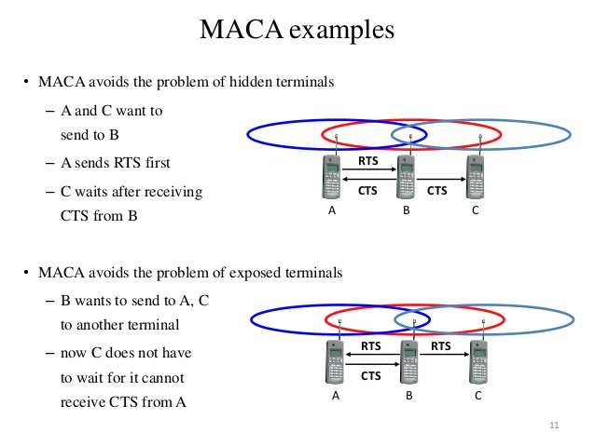

‘

* 1. **Polling**

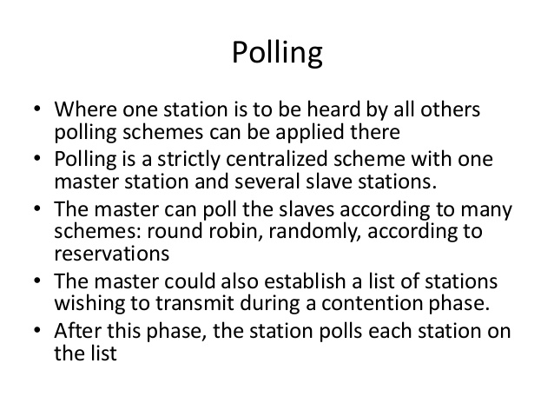

* 1. **ISMA**

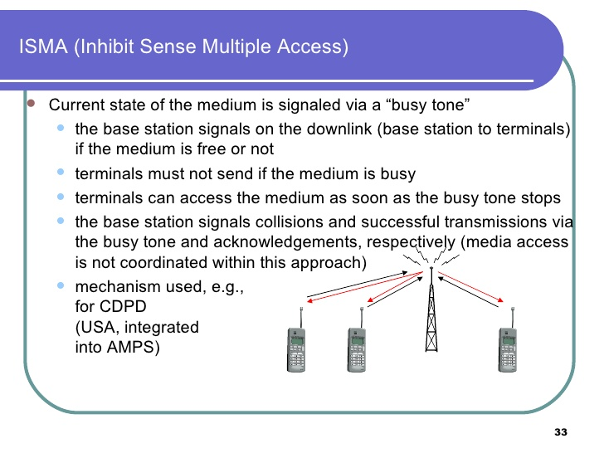

**5.CDMA**

Code division multiple access systems apply codes with certain characteristics to the transmission to separate different users in code space and to enable access to a shared medium without interference.



All terminals send on the same frequency probably at the same time and can use the whole bandwidth of the transmission channel. Each sender has a unique random number, the sender XORs the signal with this random number. The receiver can “tune” into this signal if it knows the pseudo random number, tuning is done via a correlation function

**Disadvantages:**

* higher complexity of a receiver (receiver cannot just listen into the medium and start receiving if there is a signal)
* all signals should have the same strength at a receiver

**Advantages:**

* all terminals can use the same frequency, no planning needed
* huge code space (e.g. 232) compared to frequency space
* interferences (e.g. white noise) is not coded
* forward error correction and encryption can be easily integrated